POLY/PMSE Student Chapter

Our student chapter was created in 2012, and it is affiliated to ACS POLY and PMSE divisions as well as recognized as an official organization by the University of Florida.

POLY/PMSE is a place to network, help with career development and provide opportunities to students and post-docs in the polymer field.

Our current officers (2015-2016) are:

President:

Kyle Bentz

* Primary coordination of all chapter activities
* Conduct regular meetings
* Enforce parliamentary procedures
* Encourage cooperation and participation
* File annual reports
* Represent the chapter in the POLY committee

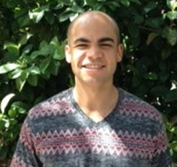

Vice President:

Adrian Figg

* Plan calendar for the year
* Act on behalf of the president
* Coordinate membership recruitment campaign
* Assist and share responsibilities as necessary with the president

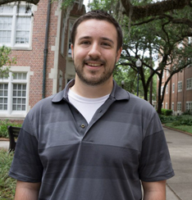Secretary: Chris Kabb

* Record minutes for all meetings
* Compile membership roster
* List committee assignments
* Handle chapter correspondence

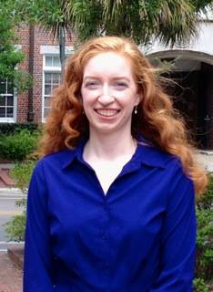

Treasurer: Jessica Cash

* Basic financial management
* Prepare tentative budget at the beginning of year
* Maintain balanced checkbook
* Report on present income at all meetings
* Record all cash advanced and handle reimbursements

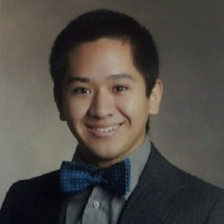

Event coordinator: Craig Machado

* General coordinator of events performed by the chapter
* Location, technology and refreshment management

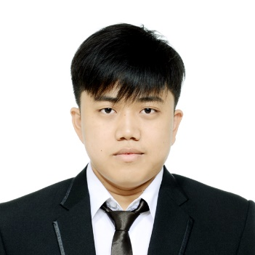

Public Relations: Steven Shen

* Communicate news and events to chapter members
* Publicize chapter activities via email, flyers, etc
* Keep student chapter board up to date

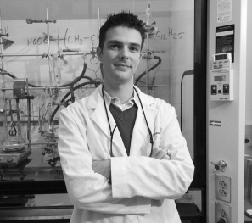Faculty advisor: Dr. Brent Sumerlin

Previous Officers

(2014-2015)

|  |  |  |  |  |  |
| --- | --- | --- | --- | --- | --- |
| President | Vice-President | Secretary | Treasurer | Event Coordinator | Public Relations |
| http://www.chem.ufl.edu/~miller/images/rostagno256.png  Mayra Rostagno | Jessica Cash | http://www.chem.ufl.edu/~miller/images/gibbons256.png  Nicole Gibbons | http://www.chem.ufl.edu/~sumerlin/images/people/group/william-brooks.jpg  Will Brooks | http://www.chem.ufl.edu/~sumerlin/images/people/group/nick-carmean.png  Nick Carmean | megan-hill.jpg  Megan Hill |

(2012-2014)

|  |  |  |  |
| --- | --- | --- | --- |
| President | Vice-President | Secretary | Treasurer |
| megan-hill.jpg  Megan Hill | http://www.chem.ufl.edu/~miller/images/rostagno256.png  Mayra Rostagno | D:\UF\Summer 2015\PolyPMSE\IMG_1683.JPG  Chris Deng | D:\UF\Summer 2015\PolyPMSE\patricia-bachler.jpg  Patricia Bachler |